Advent 2024 Revisiting the Visit of the Magi
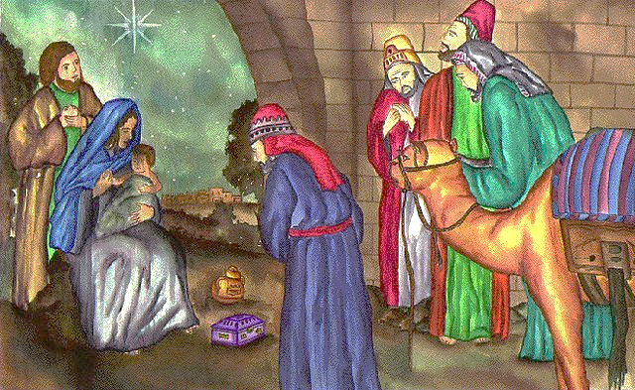
Matthew 2
After Jesus was born in Bethlehem in Judea, during the time of King Herod, Magi from the east came to Jerusalem and asked, “Where is the one who has been born king of the Jews? We saw his star in the east and have come to worship him.”
When King Herod heard this he was disturbed, and all Jerusalem with him. When he had called together all the people’s chief priests and teachers of the law, he asked them where the Christ was to be born. ”In Bethlehem in Judea,” they replied, “for this is what the prophet has written:
” ‘But you, Bethlehem, in the land of Judah, are by no means least among the rulers of Judah; for out of you will come a ruler who will be the shepherd of my people Israel.’”
Then Herod called the Magi secretly and found out from them the exact time the star had appeared. He sent them to Bethlehem and said, “Go and make a careful search for the child. As soon as you find him, report to me, so that I too may go and worship him.”
After they had heard the king, they went on their way, and the star they had seen in the east went ahead of them until it stopped over the place where the child was. When they saw the star, they were overjoyed. On coming to the house, they saw the child with his mother Mary, and they bowed down and worshiped him. Then they opened their treasures and presented him with gifts of gold and of incense and of myrrh. And having been warned in a dream not to go back to Herod, they returned to their country by another route. (NIV)
Who Were The Magi? Myth busting 101
According to the Greek historian Herodatus, living in the 5th century BC, the magi were the sacred caste of the Medes and provided priests for Persia. There is no real evidence that they were kings, or magicians - the religion of the Magi was Zoroastrianism which bans sorcery. It was their astrological skills that brought them on a journey to Jesus.
Regarding numbers, nowhere in the Gospels does it mention how many Magi made the journey, and three is often attributed to the fact that just three gifts are mentioned. There is also no mention of why those gifts were chosen, other than they were precious things fitting for a king.
The early church seems quickly to have seen the gifts of gold, frankincense and myrrh as having spiritual connections with the nature of Jesus as the Christ, and although there is a little variation in emphasis, we’ll use the following – gold as an appropriate offering to a king, frankincense as a fragrant offering to God given by a Priest, and myrrh, an embalming spice for one who has died.
As to their names we are probably in the realms of legend. From the Roman Church tradition of the seventh century we have Gaspar, Melchior, and Balthasar. Meanwhile the Syrians call them Larvandad, Hormisdas, Gushnasaph. Others use Hormizdah, Perozdh and Yazdegerd, or Basanater, Karsudan and Hor.
Matthew tells us that they came from the east, and if so then east of Palestine would mean that they came from Media, Persia, Assyria or Babylonia, as only these had a Magian priesthood. Their journey probably took them across the Syrian desert, through Aleppo, Palmyra and Damascus and southward, with the Sea of Galilee and Jordan to their west until they crossed the ford near Jericho, and then onward to Bethlehem.
The journey from Persia was a long one of around 1100 miles. There would have been considerable preparation for such a long journey which could have taken up to 12 months by camel (although camels don’t feature in the Gospel story!)
Timing-wise, it is suggested they found Jesus after he had been presented at the Temple (Luke 2:38) and just before Mary and Joseph flee to Egypt where they stayed until after Herod’s death in 4BC (Due to a slip-up in calculating the calendar in the 6th century Jesus’ actual birth year is variously suggested as being around 6 BCE).
We don’t know for sure what the Magi saw in the sky. Various suggestions have been made, including a comet, the conjunction of Jupiter and Saturn (7 BCE) Jupiter and Venus (6 BCE), or even perhaps a stella nova (a star which suddenly increases in brightness and magnitude before fading)
The Silent Whisper
However we look at the story of the magi and their gifts, it is impossible within the spiritual significance of the offerings to ignore the whisper of Easter in the breeze. The gifts of gold, frankincense and myrrh point to Jesus as King, Priest and the Man of Sorrows. For that reason alone, Advent challenges us not only to look upon the significance of God coming as a baby to walk this earth alongside his people, but also the reason for the season - that here God’s plan of Salvation takes root in a stable, surrounded not by trumpets and an army of angels, but by Mary, Joseph, some animals and a few shepherds from the local fields.
So it is that this study looks at the spiritual significance of the gifts, and ends with looking at the stable, and considers what might be a suitable gift for the Christ child.

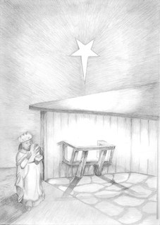
GOLD A King is Born
Gold has traditionally been seen as an appropriate gift to be offered to a king. ‘After Jesus was born in Bethlehem in Judea, during the time of King Herod, Magi from the east came to Jerusalem and asked, “Where is the one who has been born king of the Jews?’ (Matthew 2:1-2)
Of the Gospel writers, Matthew, writing particularly to a Jewish audience is the one who sees Jesus as King of the Jews, the one who fulfilled the promises of the prophets (the Messiah was expected to come from the direct ancestral line of King David) and he goes to great lengths to prove his point.
‘But you, Bethlehem Ephrathah, though you are small among the clans of Judah, out of you will come for me one who will be ruler over Israel, whose origins are from of old, from ancient times.’ (Micah 5:2)
David’s throne had remained empty for 600 years. The current king, Herod the Great had no ancestral claim on it because he was not a pure Jew, being half Edomite. Interestingly, Herod took the whole ancestral concept very seriously and had the official registers (held by the Sanhedrin) destroyed so that he could attempt to prove that there was no purer pedigree than his.
Matthews alludes to Jesus as King throughout his Gospel.
1) He uses the term ‘Son of David’ more than any of the other Gospel writers.
2) In the Sermon on the Mount (5:21ff) Jesus says of the Law ‘You have heard that it was said…’ and follows this with an authoritative ‘But I say…’
3) The triumphant entry into Jerusalem is a dramatic picture of Jesus as King (21:1-11)
4) Jesus accepts the title when Pilate asks him ‘Are you the king of the Jews?’ (27:11)
5) At the end of Matthew’s Gospel the risen Jesus tells his disciples ‘All authority in heaven and on earth has been given to me.’ (28:18)
A King and His Kingdom
The prophet Isaiah looks for a king to reign on the throne of David - for eternity; ‘For to us a child is born, to us a son is given, and the government will be on his shoulders. And he will be called Wonderful Counsellor, Mighty God, Everlasting Father, Prince of Peace. ‘Of the increase of his government and peace there will be no end. He will reign on David’s throne and over his kingdom, establishing and upholding it with justice and righteousness from that time on and forever.’ (Isaiah 9:6-7).
To Jews this kingdom is wholly in the future and is known as ‘the age to come’. When Jews celebrate the Feast of Tabernacles in September or October, they are looking forward to the coming Messiah to establish the kingdom of heaven here on earth. To a Jew the time we live in is known as the ‘present evil age’, ruled by Satan.
Christians might agree about the ‘present evil age’, but they also believe the Messiah has come and is going to come again. So the ‘age to come’ which the Jews are looking for actually began as God broke through into history in the person of Jesus, born a baby in Bethlehem. The kingdom of heaven is here, overlapping rather than replacing the ‘present evil age’.
Christians therefore live in a time of tension. The kingdom is here but not yet seen in all its fullness, it has been inaugurated but not consummated. It can however be entered, lived in and enjoyed. God’s kingdom is present wherever God’s will is done. We pray this most weeks in worship, ‘Your will be done, on earth as it is in heaven.’
Citizenship in the Kingdom
What is it like to be a citizen of God’s kingdom? It is to acknowledge the authority of God over our lives, to serve Him, to be faithful, to belong to the community of the kingdom (the church) and to be prepared for the return of Jesus. In Matthew’s Gospel we have Jesus’ teaching on life in the kingdom, particularly in the Sermon on the Mount (Chapters 5-7). Picking up on a few key verses, we see that life in the kingdom is demonstrated by our relationship to God and importantly to others:
‘You are the salt of the earth…’ (5:13)
‘…let your light shine before all people’ (5:16)
‘Do not store up for yourselves treasures on earth…’ (6:19)
‘Therefore I tell you, do not worry about your life…’ (6:25)
‘But seek first his kingdom and his righteousness…’ (6:33)
‘Do not judge, or you too will be judged.’ (7:1)
‘Ask and it will be given to you; seek and you will find…’ (7:7)
‘…do to others what you would have them do to you’ (7:12)
‘…by their fruit you will recognize them’ (7:20)
That’s life in the kingdom. Its priorities are God-centred rather than self-centred (which is the way of the world). It means lives lived out in service to the King!
The Numbers Game
Matthew’s genealogy in chapter 1 is neatly divided into three groups of 14, which as well as making it easier for listeners to remember has significance for Jews.
The first group takes the story up to David (the rise of Israel’s greatest king). The second group takes the story forward to exile in Babylon (Israel’s lowest point, a time of great shame and misery) and the third group brings the story up to the time of Jesus (who liberates humankind from slavery and turns tragedy into triumph)
In the Hebrew alphabet letters double up as numbers. The consonants in the name David in Hebrew are D W D which stand for 4+6+4 and add up to 14. Matthew’s claim is that there are 14 generations from Abraham to David, from David to the exile, and from the exile to the coming of Jesus as King.

Questions to ponder
- How does Jesus as King challenge us, and is there another description which you find easier to connect with - for example Good Shepherd, Saviour, Messiah, Prince of Peace, Bread of Life and if so, why?
- If Jesus is King, what responsibilities does that infer for his subjects?
- Are you happy with the description of the times you live in as ‘This Present Evil Age’? If no, then how would you describe them? If yes, how does (or should) the kingdom of God impact upon it?
- How should Jesus’ teaching on ‘life in the kingdom’ affect our life as a church community?

