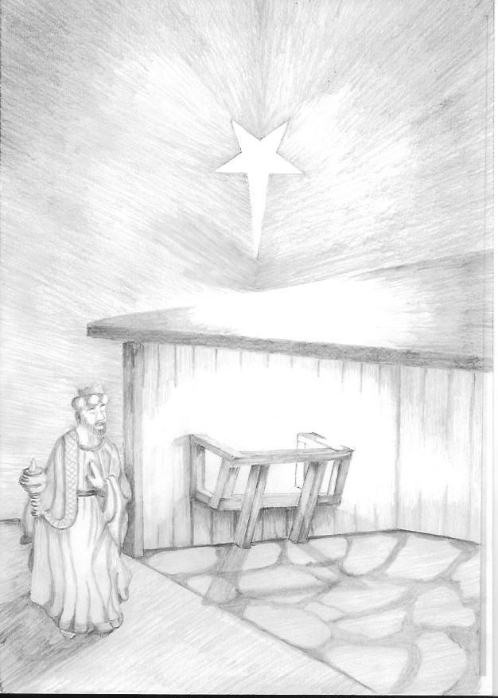
FRANKINCENSE A Fragrant Offering
We first come across frankincense in Exodus: ‘Then the LORD said to Moses, “Take fragrant spices—gum resin, onycha and galbanum—and pure frankincense, all in equal amounts, and make a fragrant blend of incense, the work of a perfumer. It is to be salted and pure and sacred. Grind some of it to powder and place it in front of the Testimony in the Tent of Meeting, where I will meet with you. It shall be most holy to you.’ (Exodus 30:34-36)
When the magi offered this gift there may well have been no other significance than that this was a suitable gift for the birth of a King, they were after all not Jews.
Just as frankincense burns freely, leaving nothing behind, so Jesus willingly and freely offered himself as a fragrant offering and sacrifice. We could extend the analogy further by saying that frankincense is obtained in the wounding of a tree by cutting into its bark, and Jesus was of course wounded, scourged and hung upon a tree.
At the centre of this gift is its use by the priest to present a fragrant offering in the temple, and within it the thoughts of purity and holiness as expressed in the passage from Exodus.
Jesus as High Priest
How do we make the connection between the gift and the picture of Jesus as High Priest? Well, we have to go back into the history of God’s dealings with the people of Israel. In Exodus we read that a covenant was established between God and his people, a special relationship based upon observance to the law which God had given. (Exodus 24:3-8).

Breaking the law was sin, which put a barrier between God and His people. To overcome this barrier the Levitical priesthood and sacrifices were introduced. Law given – humankind sins – barrier raised – sacrifice offered – relationship restored. Good idea, but there was always an understanding that at its best sacrifice only atoned for sins of ignorance and not for deliberate sins. Even our limited experience of life tells us that such a sacrificial system could never permanently restore humankind’s relationship with God, for the simple reason that we continually fall short. Sacrifice would have to go on and on for ever, simply because we keep re-erecting that barrier.
What was needed was a perfect priest and perfect sacrifice. Someone who could offer to God once and for all a sacrifice that would allow access to God, restore broken relationships and atone for the sins of humanity. Not too much to ask, is it? Enter Jesus into the world!
The Perfect Priest
The writer to the Hebrews had spent a long time studying the concept of Jesus as the perfect Priest. It is not an easy book to understand, as the writer acknowledges, but from his book we get an idea of what he considers to be the job description of a priest.
1) Firstly, you don’t just decide to be a priest. It is a calling, implying that God has chosen someone and is waiting for them to hear his voice and respond. ‘No one takes this honour upon himself; he must be called by God’ Hebrews 5:4
2) A priest is to be ‘of the people’, someone who has known the ups and downs of life, its joys and temptations. How else can they feel empathy with those who come to them, and help those who are struggling with life? ‘deal gently with those who are ignorant and are going astray, since he himself is subject to weakness.’ Hebrews 5:2
3) The writer looks at the role of a priest as a link between humankind and God. ‘selected and is appointed to represent them in matters related to God, to offer gifts and sacrifices for sins.’ Hebrews 5:1
Ticking the Boxes
The writer to the Hebrews is concerned to show that in all aspects Jesus fulfils the requirements when it comes to suitability for the post. So what do we know about Jesus?
1) We know that Jesus was acknowledged as God’s Son at his baptism in the Jordan.
‘As Jesus was coming up out of the water, he saw heaven being torn open and the Spirit descending on him like a dove. And a voice came from heaven: “You are my Son, whom I love; with you I am well pleased.”’ (Mark 1:11,12)
2) We also know that Jesus was very much flesh and blood, as the evidence is laid out for us throughout Scripture. We read of his growing up, interactions with his parents and siblings, temptations in the desert, the fellowship and discussions he enjoyed with friends and disciples, arguments with the authorities, his grief at hearing of the death of Lazarus and the pain he endured before and during his crucifixion. He was in a very real sense ‘a person’. ‘For we do not have a high priest who is unable to sympathize with our weaknesses, but we have one who has been tempted in every way, just as we are—yet was without sin. Let us then approach the throne of grace with confidence, so that we may receive mercy and find grace to help us in our time of need.’ (Hebrews 4:15,16)
3) Who better to be the link between God and humankind, because of who Jesus is?
Jesus can bring us to God, and bring God to us because in him God entered into our world and time. To see Jesus is to see what God is like.
The Perfect Sacrifice
Jesus is the perfect sacrifice because of his sinless nature. The sacrifice, freely given, never needs to be made again. The writer to the Hebrews sums up his thoughts on the subject like this, ‘So Christ has now become the High Priest over all the good things that have come. He has entered that greater, more perfect Tabernacle in heaven, which was not made by human hands and is not part of this created world. With his own blood—not the blood of goats and calves—he entered the Most Holy Place once for all time and secured our redemption forever.’ Under the old system, the blood of goats and bulls and the ashes of a young cow could cleanse people’s bodies from ceremonial impurity. Just think how much more the blood of Christ will purify our consciences from sinful deeds so that we can worship the living God.
Questions to Consider
- When you pray, do you have a picture in your mind of Jesus as Priest?

- Is that a helpful image or not, when we are so remote from the sacrificial worship that was at the heart of the temple?

- Basic Christian doctrine asserts that Jesus was fully human and fully divine. How crucial to your faith is Jesus being ‘of the people’, the phrase that the writer to the Hebrews uses to describe the qualities of a priest?

- If the sweet-smelling frankincense resin comes as the result of the tree’s woundedness and pain, what does this suggest for Christian worship and life?

