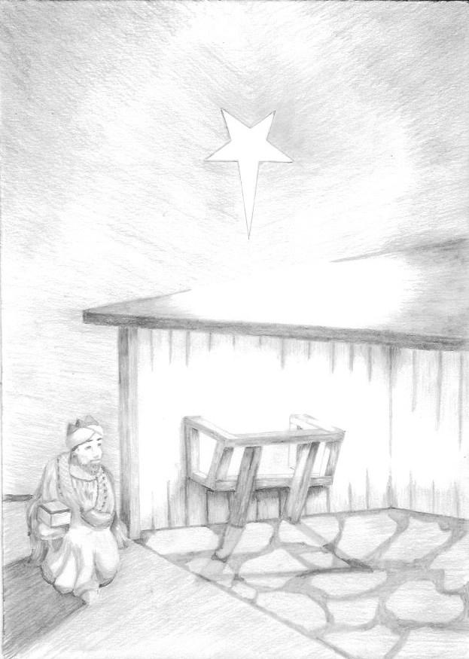
MYRRH Man of Sorrows
Did you know? The name myrrh comes from the Arabic word ‘morr’ and the Hebrew ‘marar’ which mean ‘bitter’. In traditional Chinese medicine myrrh is used as a wound healer, for menstrual blockages, hemorrhoids, as well as pain and stiffness, swelling, bruising, blood stagnation and as a dissolvent for masses and fibroids.
Myrrh was a popular perfume and reported to keep its fragrance for several hundred years when kept in an alabaster pot. St. Nicholas, Archbishop of Myra in Lycia (now in Turkey) was a 4th-century miracle-worker, apparently known also for the healing myrrh that flowed from his sacred relics. Myrrh was offered to Jesus as he hung on the Cross (Mark 15:23, Matthew 27:34)
Because of its association with death and burial, the magi’s gift of myrrh has been associated with the sufferings of Jesus and the sacrificial nature of his life and death. Biblical scholars have looked back into the Scriptures and found passages which appear to prefigure the life of Jesus. As we read the Old Testament, we hear within it whispers of the future Christ child.
Anyone who has read only the briefest description of the scourging that Jesus received at the hands of his captors, or the agonizing process of death by crucifixion, will have some idea of the fear and resolve that was in Jesus’ mind as he made his way into Jerusalem for the last time.
As Christians we have to appreciate that this was the place that Jesus was journeying toward from the very moment of his birth. The thought of Jesus as sacrifice is a difficult one for some. But this is something which has such resonance in the whole story of God’s dealings with His people, because they understood the significance of sacrificial worship, which at its heart involved the spilling of blood.
A New Covenant
The sacrificial system under the old covenant was at best only a temporary solution because it had to be repeated time after time, and could not deal with the deep sins of the heart. God had, however promised a new covenant,
This new covenant would be different in that God says, ‘I will forgive their wickedness and will remember their sins no more.’ (Jeremiah 31:34). Now put those words together with those of the writer to the Hebrews who says that Jesus is ‘the mediator of a new covenant.’ (Hebrews 12:24). What does a mediator do, other than bring two parties together? The message of the New Testament (and in Greek, Testament and Covenant have the same meaning) is that Jesus came with the single purpose of bringing humankind back into a relationship with God through this new covenant.
Myrrh reminds us of the suffering that Jesus freely accepted, so that he might be the means by which God might be able to ‘forgive their wickedness and will remember their sins no more.’ In doing so He accepts us as the Prodigal Son’s father did, with open arms and a loving heart.
A Passover Connection
Myrrh, unlike frankincense is bitter, and there is an interesting spiritual connection between this ‘bitterness’ and the bitter herbs eaten at a Passover Seder meal described in Exodus chapter 12. One lamb was slain for every household and the blood painted onto the lintels and doorposts. This was done in order that the angel of Death would not slay the first-born son of the Jewish households, but only those of Pharoah’s people whom God had warned He would judge. “When I see the blood, I will pass over you” the Lord told the children of Israel (Exodus 12:13). They were to eat the lamb, together with unleavened bread and bitter herbs, in haste prior to their departure from Egypt.
Since those days Jews have remembered the Passover faithfully each year, in remembrance of their deliverance from slavery. Today during the meal, they will dip the bitter herbs (probably parsley) into salt water to remember the tears as ‘The Israelites groaned in their slavery and cried out, and their cry for help because of their slavery went up to God’ (Exodus 2:23) Messianic (Christian) Jews may still celebrate the Passover meal, but as they eat the lamb and bitter herbs will pray something like ‘Let us now eat and remember the grace, mercy and love that God has for each of us, for He sent Yeshua, our Messiah, to be our Passover Lamb. We too, like the Israelites released from the bondage of slavery, can be saved from the bondage of sin.’
One more sacrifice was necessary, the climax to a plan of salvation which God had gradually unveiled through the rituals and ceremonies of the Old Testament books. The clearest revelation possible of God’s love. Not a tragedy, not a failure, but a victory over death and sin. ‘Christ, our Passover Lamb, has been sacrificed for us’ (1 Corinthians 5:7)
God and Suffering
We have considered Jesus’ suffering, but of course there is so much suffering in this world of ours. How do we address the question of why a loving God allows suffering?
We can perhaps all name someone who seems to have recovered almost miraculously from an illness, whilst knowing of many for whom many prayers for healing appear to have gone unanswered. There are of course no easy answers, and not enough space here to do more than merely touch upon the subject.
Martin Luther told his followers, ‘Even in the best of health we should have death always before our eyes [so that] we will not expect to remain on this earth forever, but will have one foot in the air, so to speak.’
A City That Knew Suffering
The Greek word for myrrh is the same as that of the ancient city of Smyrna, which lies in what is now modern Turkey. Smyrna was the subject of one of John’s letters in Revelation, distinguished by being a persecuted church which knew the bitterness of suffering for the sake of the Gospel.
Questions to ponder
- Would it have been preferable to use other properties of myrrh as an image for Jesus’ life to come - its healing properties, or perhaps its use in expensive perfume?

- Many people, and those of other faiths, cannot understand the concept of God’s Son being born on earth only to grow up to suffer a cruel punishment and be killed. How would you explain in simple terms why the baby at the heart of Christmas was destined to be the centre of our Easter story?

- How do you approach the question of suffering in this world?

- How easy is it to pray for healing if you have known friends for whom there seems to have been no answer?

