


July 2025
Casa Bob, Calle Cardon, 76
My intention of writing more frequently has as yet failed to materialize. I realised while in the UK seeing the family that it was April when I last wrote, so my apologies, but life continues to move at it’s own pace in the chaplaincy.
So, a quick recap of what has been happening since that April update.
In Holy Week, I (with Chris, Bob and Judie) attended the Chrism Mass in St George’s Madrid. It had been meant to include being welcomed to the role of Area Dean by Bishop Robert, but as ever things did not go to plan. However it was good to meet with old and new friends from across the Diocese and get to see something of the city of Madrid.
We marked Mandy Thursday with a quiet service at the home of Ann and David Reed and I do offer my heartfelt thanks to them for allowing us to worship there when the restaurant is unavailable. I was delighted that this year we were permitted to have a Good Friday service in the Church in Corralejo, with grateful thanks to Fr Ivan for being so welcoming. A few of us did brave the early morning of Easter day at the beach in Lajas, and both our services were well attended.
At the end of April, we had our Annual Church Council meeting, which saw Robert Swift standing down as churchwarden and Graham Maclean being elected in his place and John Vine being re-elected. My thanks to Robert and John for their help and support over the last year and my heartfelt thanks to Graham for his willingness to take on the role.
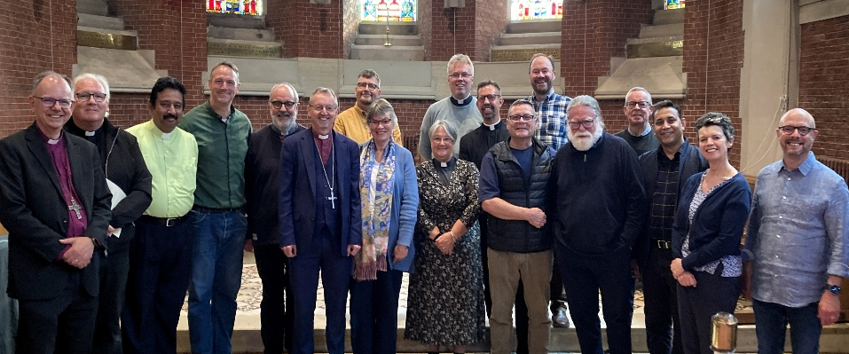
In May, I (with Chris, as personal travel assistant) travelled to Brussels for the Annual Area Dean’s meeting. I was finally formally welcome to the role by Bishop Robert at evening prayer in All Saints Church. At the meeting the role definition for Area Dean was shared and discussed, and both Bishops Robert and Andrew spent time speaking about the challenges and joys of being part the largest and most diverse Diocese in the Church of England.
Life as an Area Dean is both interesting and challenging. I have had several trips to Lanzarote recently and am looking forward to heading to Tenerife South, next month. Both Chaplaincies are now seeking new Chaplains to lead them, so I would ask you to hold them in your prayers at this time of transition.
So, as I said at the beginning, life as ever goes on. We live in challenging and very worrying times, but in all of this, I know that God is with us and for us. That walking in the faith of Christ, each and every day, may not change the worries and challenges of the world, but it does bring a sense of peace that this world can never give. May the Lord Bless you and keep you, and may you know that peace. Amen.
Revd Canon Anne Brown
+34 711007318
chaplain@fuertechurch.org

