
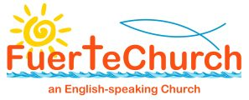

December 24
Casa Bob, Calle Cardon, 76
The Blessings of the season of Advent be with you!
Waiting, is there overarching theme of Advent, but I am sorry that this letter has been rather a long time in coming. The main reason for that is because I was waiting for the Christmas Services to be confirmed.
However, before I come to that, I would like to take a few months to reflect on the year, and it has been rather busy. We have run the Bible Course, and Christianity Explored and will complete the Romans Course early January. We have looked into Revelation, both in Corralejo and Caleta de Fuste and spent a couple of weeks looking at the Book of Jonah. We are now meeting regularly for the bring and share lunches and have had a couple of prayer events this year. We have also managed to gain both the Bronze and then Sliver awards from Eco Church. As I say it has been a busy year.
I would like to thank everyone, who has in some way, supported the chaplaincy over the last year. Those who help to ensure worship takes place week by week; those who help put up and take down for worship; those who lead; those who read and pray; those who come to worship; those who record the service and make sure it is available for other to watch; those who support us with prayers and donations; those on the council. Those who come to coffee and chat; beer club; bible study; aqua fit; chaplaincy lunches or any of the events we host. In fact, everyone. For you all in some way make this chaplaincy work as well as it does.
This year, the Chaplaincy will be donating 3000 euros to the Cancer Charity at our special service this Sunday, 15th, which includes £862 raised from the Christmas Fayre by Sue Thronber and her wonderful team
Without you, and your help, your support, our Chaplaincy would not be great the place it is, and we could not have done all we have.
So, to Christmas Services, we have the following,
Friday 20th 6pm Carols at Casa Pablos, Tamaragua
Saturday 21st 5pm Carols at The Chocolate Box, Caleta de Fuste
Sunday 22nd 5pm Carols and Communion at Corralejo
Christmas Eve 5pm Christmas Communion at Corralejo
I am very grateful to Fr Ivan who has permitted us to have a service on Christmas Eve.
Hopefully if you are on the island you will be able to join in one or two of the services, but wherever you are, you know the hope, peace, joy and love of the Christmas season.
Love and many prayers
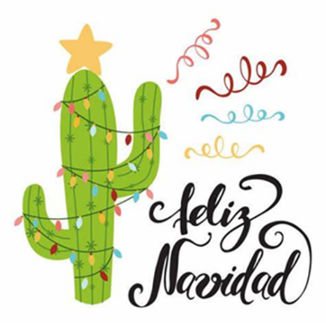
Anne x
Revd Canon Anne Brown
+34 711007318
chaplain@fuertechurch.org

